Physical Science Fall 2016 Practice

Multiple Choice
Identify the choice that best completes the statement or answers the question.

____ 1. How are science and technology related?
a. | Technology is a branch of natural science.
b. | Science is a branch of technology.
c. | Advances in science may lead to advances in technology and vice versa.
d. | Science and technology are not related.

____ 2. How does Earth science overlap with life science?
a. | Earth science involves the study of Earth’s rocks.
b. | Earth science involves the study of systems that may include living organisms.
c. | Earth science involves the study of the composition of matter.
d. | Earth science does not overlap with life science.

____ 3. What are the building blocks of all matter?
a. | forces | c. | magnetic fields
b. | atoms | d. | kinetic and potential energy

____ 4. What happens when the data in an investigation do not support the original hypothesis?
a. | The scientist gives up and starts an investigation on a new topic.
b. | The data must be incorrect and are thrown out.
c. | The hypothesis is revised.
d. | The data are altered so that they support the original hypothesis.

____ 5. Which of the following statements is true about scientific theories?
a. | Scientific theories become scientific laws.
b. | Scientific theories are never proven.
c. | Scientific theories become hypotheses.
d. | Scientific theories summarize patterns found in nature.

____ 6. Why are scientific models important?
a. | They prove scientific theories.
b. | They help visualize things that are very complex, very large, or very small.
c. | They make it harder to understand things.
d. | They never change.

____ 7. Which of the following is an example of a safe laboratory procedure?
a. | tying back long hair and loose clothing
b. | eating or drinking from laboratory glassware
c. | touching hot objects with your bare hands
d. | testing an odor by directly inhaling the vapor

____ 8. Which of the following conversion factors would you use to change 18 kilometers to meters?
a. | 1000 m/1 km | c. | 100 m/1 km
b. | 1 km/1000 m | d. | 1 km/100 m

____ 9. There are 1660 megawatts of wind-generated electricity produced globally every year. This amount is equivalent to
a. | 1,660,000 watts | c. | 16,600,000 watts
b. | 1,660,000 kilowatts | d. | 166,000 kilowatts

____ 10. Which of the following clocks offers the most precision?
a. | a clock with only one hand to measure the hour
b. | a clock with only one hand to measure the minutes
c. | a clock with a hand to measure the hour and a hand to measure the minutes
d. | a clock with a hand to measure the hour, a hand to measure the minutes, and a hand to measure the seconds

____ 11. Approximately how many kelvins are equal to 60°F?
a. | 333 | c. | 413
b. | 323 | d. | 289

____ 12. How do scientists who speak different languages make their data understandable to one another?
a. | They all use different systems of measurement.
b. | They all use SI.
c. | They communicate through a universal translator.
d. | They all must speak French.

____ 13. A passenger in the rear seat of a car moving at a steady speed is at rest relative to
a. | the side of the road. | c. | the front seat of the car.
b. | a pedestrian on the corner ahead. | d. | the wheels of the car.

____ 14. A person drives north 6 blocks, then turns west, and drives 6 blocks. The driver then turns south and drives 6 blocks. How could the driver have made the distance shorter while maintaining the same displacement?
a. | by driving west 6 blocks from the starting point
b. | by driving north 4 block and west 7 blocks
c. | by driving south 6 blocks from the starting point
d. | by driving back to the starting point by the same route

____ 15. Displacement vectors of 4 km south, 2 km north, 5 km south, and 5 km north combine to a total displacement of
a. | 16 km north | c. | 6 km south
b. | 11 km west | d. | 2 km south

____ 16. Speed is the ratio of the distance an object moves to
a. | the amount of time needed to travel the distance.
b. | the direction the object moves.
c. | the displacement of the object.
d. | the motion of the object.

____ 17. A car traveled 60 km in 2 hours, 84 km in the next 1 hour, and then 68 km in 2 hours before reaching its destination. What was the car’s average speed?
a. | 212 km/h | c. | 148 km/h
b. | 42 km/h | d. | 1060 km/h

____ 18. Vector addition is used when motion involves
a. | more than one direction. | c. | more than one speed.
b. | more than one velocity. | d. | all of the above

____ 19. Which example identifies a change in motion that produces acceleration?
a. | a speed skater moving at a constant speed on a straight track
b. | a ball moving at a constant speed around a circular track
c. | a particle moving in a vacuum at constant velocity
d. | a vehicle moving down the street at a steady speed

____ 20. Which example describes constant acceleration due ONLY to a change in direction?
a. | increasing speed while traveling around a curve
b. | an object at rest
c. | traveling around a circular track
d. | an object in free fall

____ 21. An object moving at 30 m/s takes 5 s to come to a stop. What is the object’s acceleration?
a. | 30 m/s² | c. | –6 m/s²
b. | –30 m/s² | d. | 6 m/s²

____ 22. A train approaching a crossing changes speed from 25 m/s to 10 m/s in 240 s. How can the train’s acceleration be described?
a. | The train’s acceleration is positive.
b. | The train is not accelerating.
c. | The train will come to rest in 6 minutes.
d. | The train’s acceleration is negative.

____ 23. Which of the following statements is true?
a. | An object that is accelerating is always changing direction.
b. | An object has an instantaneous acceleration, even if the acceleration vector is zero.
c. | An object at rest has an instantaneous acceleration of zero.
d. | Instantaneous acceleration is always changing.

____ 24. Which of the following relationships is correct?
a. | 1 N = 1 kg | c. | 1 N = 1 kg·m/s
b. | 1 N = 1 kg·m | d. | 1 N = 1 kg·m/s²

____ 25. When a pair of balanced forces acts on an object, the net force that results is
a. | greater in size than both forces combined.
b. | greater in size than one of the forces.
c. | equal in size to one of the forces.
d. | equal to zero.

____ 26. As you push a cereal box across a tabletop, the sliding friction acting on the cereal box
a. | acts in the direction of motion.
b. | equals the weight of the box.
c. | is usually greater than static friction.
d. | acts in the direction opposite of motion.

____ 27. An open parachute increases air resistance of a falling sky diver by
a. | decreasing the weight of the diver. | c. | increasing the terminal velocity.
b. | increasing surface area. | d. | reducing fluid friction.

____ 28. Projectile motion is caused by
a. | the downward force of gravity.
b. | an initial forward velocity.
c. | a final vertical velocity.
d. | the downward force of gravity and an initial forward velocity.

____ 29. If a force of 12 N is applied to an object with a mass of 2 kg, the object will accelerate at
a. | 0.17 m/s². | c. | 6 m/s².
b. | 24 m/s². | d. | 12 m/s².

____ 30. In which of the following are action and reaction forces involved?
a. | when a tennis racket strikes a tennis ball
b. | when stepping from a curb
c. | when rowing a boat
d. | all of the above

____ 31. What is the momentum of a 50-kilogram ice skater gliding across the ice at a speed of 5 m/s?
a. | 10 | c. | 50 kg
b. | 500 kg·m/s | d. | 250 kg·m/s

____ 32. The gravitational force between two objects increases as mass
a. | decreases or distance decreases. | c. | increases or distance decreases.
b. | decreases or distance increases. | d. | increases or distance increases.

____ 33. Two identical test tubes are filled with equal volumes of water and mercury. Which of the following statements is true?
a. | The weight of both liquids is the same.
b. | The bottom area of both test tubes is the same.
c. | The pressure at the bottom of both test tubes is the same.
d. | All of the above.

____ 34. The pressure of air at sea level is approximately
a. | 0 kPa. | c. | 101 kPa.
b. | 10 kPa. | d. | 1000 kPa.

____ 35. Where will the greatest increase in pressure occur if you squeeze the middle of an upright, closed soft-drink bottle?
a. | The greatest increase in pressure will occur at the top of the bottle.
b. | The greatest increase in pressure will occur in the middle of the bottle.
c. | The greatest increase in pressure will occur on the bottom of the bottle.
d. | The pressure will increase equally everywhere within the bottle.

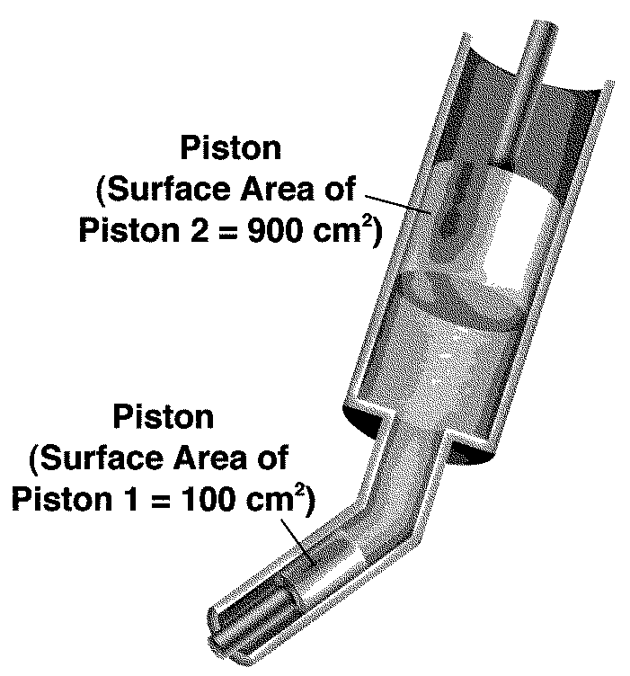

Figure 13-1

____ 36. In Figure 13-1, Piston 1 exerts a pressure of 10 Pa on the fluid in the hydraulic lift. What is the fluid pressure on Piston 2?
a. | 1 Pa | c. | 10 Pa
b. | 5 Pa | d. | 90 Pa

____ 37. Which of the following states Bernoulli’s principle?
a. | As the speed of a fluid decreases, the pressure within the fluid decreases.
b. | As the speed of a fluid increases, the pressure within the fluid decreases.
c. | As the speed of a fluid changes, the pressure of the fluid remains constant.
d. | none of the above

____ 38. Which of the following statements is true about an airplane wing during flight?
a. | Air above the wing travels faster than air below the wing.
b. | Air below the wing travels faster than air above the wing.
c. | The wing exerts pressure equally in all directions.
d. | The lift acting on the wing reduces the weight of the wing.

____ 39. A brick weighs 26 N. Measured underwater, it weighs 11 N. What is the size of the buoyant force exerted by the water on the brick?
a. | 37 N | c. | 11 N
b. | 26 N | d. | 15 N

____ 40. A cork is floating in salty water. As more salt is added to the water to increase its density, the cork will
a. | float at a higher level in the water. | c. | sink.
b. | float at a lower level in the water. | d. | float at the same level in the water.

____ 41. Two identical corks float in separate beakers. One beaker contains distilled water. The other contains very salty water. Which of the following statements is true?
a. | The corks float at the same level in both liquids.
b. | The cork in the very salty water floats at a lower level than the other cork.
c. | The corks will eventually sink.
d. | Both corks are subject to the same buoyant force.

____ 42. A force acting on an object does no work if
a. | a machine is used to move the object.
b. | the force is not in the direction of the object’s motion.
c. | the force is greater than the force of friction.
d. | the object accelerates.

____ 43. If you exert a force of 10.0 N to lift a box a distance of 0.9 m, how much work do you do?
a. | 0.1 J | c. | 10.9 J
b. | 9.0 J | d. | 90.0 J

____ 44. A 750-W motor might also be rated as a
a. | 0.5-horsepower motor.
b. | 1-horsepower motor.
c. | 2-horsepower motor.
d. | 10-horsepower motor.

____ 45. When a machine does work, it cannot do which of the following?
a. | change the direction of a force.
b. | increase a force and change the distance a force moves.
c. | increase the distance a force moves and change the direction of a force.
d. | increase a force and increase the distance a force moves an object.

____ 46. How can you make the work output of a machine greater than the work input?
a. | by decreasing friction
b. | by increasing the input force
c. | by increasing the output distance
d. | none of the above

____ 47. The efficiency of a machine is always less than 100 percent because
a. | a machine cannot have an IMA greater than 1.
b. | some work input is lost to friction.
c. | the work input is too small.
d. | the work output is too great.

____ 48. A motor with an efficiency of 75 percent must supply 240 J of useful work. What amount of work must be supplied to the motor?
a. | 75 J | c. | 320 J
b. | 180 J | d. | 420 J

____ 49. Which of the following is an example of a wheel and axle?
a. | hammer
b. | an automobile steering wheel
c. | a jar lid
d. | a pencil

____ 50. A machine is classified as a compound machine if it
a. | has moving parts.
b. | has an IMA greater than 1.
c. | is made up of two or more simple machines that operate together.
d. | is very efficient.

Completion
Complete each statement.

51. In scientific notation, (6.2 ) × (3.3 ) equals ____________________.

52. A temperature of 34ºF is equal to ____________________ kelvins.

53. The velocity of an object moving in a straight line changes at a constant rate when the object is experiencing constant ____________________.

54. Accelerated motion is represented by a(an) ____________________ line on a distance-time graph.

55. When a falling object reaches terminal velocity, the net force acting on it is ____________________.

56. The observation that a charged object can attract or repel other charged objects led scientists to conclude that there are ____________________ types of charges.

57. A pascal, the SI unit of pressure, is equal to 1 newton per ____________________.

58. As a liquid is added to a beaker, the pressure exerted by the liquid on the bottom of the beaker ____________________.

59. The watt and the horsepower are both units of ____________________.

60. The mechanical efficiency of any machine is always ____________________ than 100 percent.

Short Answer

61. A child rolls a ball 6 m across a room. The ball hits the wall and rolls halfway back toward the child. Using vector addition, calculate the ball’s displacement.

62. Bus A travels 275 m in 13 s. Bus B travels 290 m in 13 s. Both vehicles travel at constant speed. How do the distance-time graphs for these two speeds differ?

63. What types of changes in motion cause acceleration?

64. How can an arrow be used to represent the size and direction of a force?

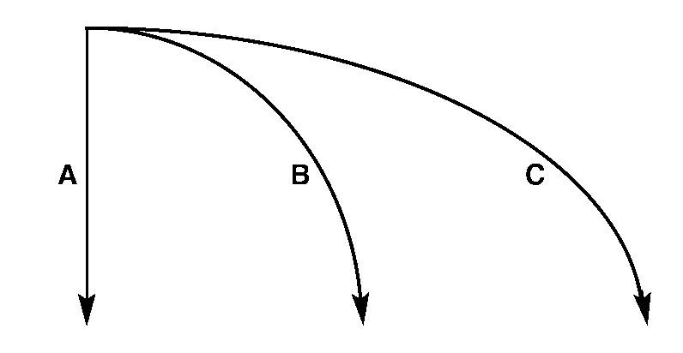

Figure 12-1

65. Figure 12-1 shows the paths followed by three balls. Each ball started moving at the same time. Ball A was dropped and balls B and C were thrown sideways. Compare the times for each ball to reach the ground.

66. A billiard ball with a momentum of 20 kg·m/s strikes a second ball at rest and comes to a complete stop. What is the change in momentum of the second ball?

67. Compare the speed of a moving golf ball with the speed of a moving bowling ball if both balls have the same amount of momentum.

68. If you know the air pressure exerted on a tabletop, how can you calculate the force exerted on the tabletop?

69. Rank the following measurements in order of increasing pressure:
4 kPa, 16 N/m², 311 N/m², 0.3 Pa

70. Why aren’t organisms that live on the seafloor crushed by water pressure?

71. A ball of clay sinks when placed in water. The same piece of clay floats if it is made into the shape of a boat. Compare the volume of water displaced by the ball with the volume displaced by the boat shape.

72. How are density and buoyancy related?

73. If you use a spring scale to measure the weight of a submerged object that has neutral buoyancy, what will the scale read?

74. Why is the work output of a machine never equal to the work input?

75. If a simple machine could be frictionless, how would its IMA and AMA compare?

76. Compare the effects of a fixed pulley and a movable pulley on the size and direction of the input force.

77. In a compound machine made up of two simple machines, how is the work output of the first simple machine related to the work input of the second simple machine?

Problem

78. A tow truck exerts a net horizontal force of 1050 N on an 760-kilogram car. What is the acceleration of the car during this time? Show your work.

79. The mass of a newborn baby is 3.5 kilograms. What is the baby’s weight? (The acceleration due to gravity at Earth’s surface is 9.8 m/s².) Show your work.

80. A 38-kilogram canoe broke free of its dock and is now floating downriver at a speed of 2.2 m/s. What is the canoe’s momentum? Show your work.

81. A small engine causes a 0.3-kg model airplane to accelerate at a rate of 11 m/s². What is the net force on the model airplane? Show your work.

82. The dimensions of a brick that weighs 25 N are 0.19 m × 0.07 m × 0.095 m. What pressure does the brick exert on the ground if it is resting on its largest face? Show your work.

83. Express a pressure of 8200 N/m² in kilopascals.

Figure 13-1

84. In Figure 13-1, a force of 150 N is exerted on Piston 1 of the hydraulic lift shown. What force will be exerted on Piston 2? Show your work.

85. A worker uses a cart to move a load of bricks weighing 680 N a distance of 10 m across a parking lot. If he pushes the cart with a constant force of 209 N, what amount of work does he do? Show your work.

86. A girl lifts a 160-N load a height of 1 m in a time of 0.5 s. What power does the girl produce? Show your work.

87. The input force of a pulley system must move 8.0 m to lift a 3000-N engine a distance of 2.0 m. What is the IMA of the system? Show your work.

88. A 20-N force applied to the handle of a door produces a 44-N output force. What is the AMA of the handle? Show your work.

89. A force of 11 N is applied to the handle of a screwdriver being used to pry off the lid of a paint can. As the input force moves through a distance 0.3 m, the screwdriver does 3 J of work on the lid. What is the efficiency of the screwdriver? Show your work.

Essay

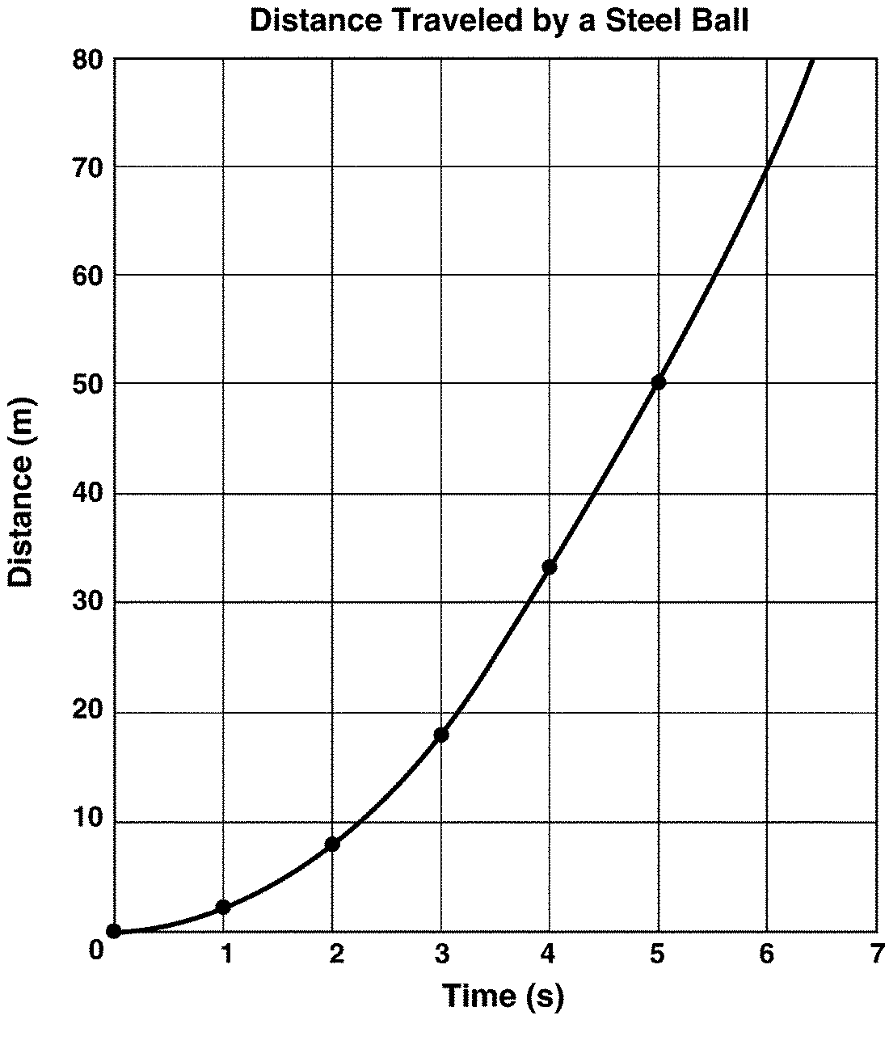
Figure 1-1

90. Figure 1-1 shows how a steel ball moved during an experiment. Average speed is calculated by dividing total distance by time. Did the steel ball speed up, slow down, or remain at the same speed throughout the experiment?

91. What is the difference between a scientific law and a scientific theory?

92. Explain how peer reviews are important in either supporting a hypothesis or revising a hypothesis.

93. Explain how velocity is different from speed.

94. Picture a ball traveling at a constant speed around the inside of a circular structure. Is the ball accelerating? Explain your answer.

95. A girl walks from her home to a friend’s home 3 blocks north. She then walks 2 blocks east to the post office, 1 block north to the library, and 1 block east to the park. From the park, she walks 2 blocks west to the movie theater. After the movie, she walks 4 blocks south to the pet store. What is the girl’s displacement from her starting point to the pet store? Where is the location of the pet store in relation to her home? Calculate the distance she walked in blocks.

96. Why does a biker have to pedal harder to travel at a constant speed into the wind on a windy day compared to traveling on the same road at the same speed on a calm day?

97. To prevent a window from exploding outward during a strong windstorm, it is left slightly open. Explain why a slightly open window might not blow out.

98. A cube of wood displaces half its volume when floating in water. When a 0.5-N washer is added to the cube, it floats just at the point where it is completely submerged in the water. What is the buoyant force acting on the cube when the washer is removed?

Physical Science Fall 2016 Practice
Answer Section

MULTIPLE CHOICE

1. ANS: C PTS: 1 DIF: L2 OBJ: 1.1.1
STA: 18.12.5

2. ANS: B PTS: 1 DIF: L2 OBJ: 1.1.2

3. ANS: B PTS: 1 DIF: L2 OBJ: 1.1.3

4. ANS: C PTS: 1 DIF: L2 OBJ: 1.2.1

5. ANS: B PTS: 1 DIF: L2 OBJ: 1.2.2

6. ANS: B PTS: 1 DIF: L2 OBJ: 1.2.3

7. ANS: A PTS: 1 DIF: L2 OBJ: 1.2.4

8. ANS: A PTS: 1 DIF: L2 OBJ: 1.3.1

9. ANS: B PTS: 1 DIF: L2 OBJ: 1.3.2

10. ANS: D PTS: 1 DIF: L2 OBJ: 1.3.3

11. ANS: D PTS: 1 DIF: L2 OBJ: 1.3.4

12. ANS: B PTS: 1 DIF: L2 OBJ: 1.4.3

13. ANS: C PTS: 1 DIF: L2 OBJ: 11.1.1

14. ANS: A PTS: 1 DIF: L2 OBJ: 11.1.3

15. ANS: D PTS: 1 DIF: L2 OBJ: 11.1.4

16. ANS: A PTS: 1 DIF: L2 OBJ: 11.2.1

17. ANS: B PTS: 1 DIF: L2 OBJ: 11.2.2

18. ANS: D PTS: 1 DIF: L2 OBJ: 11.2.5

19. ANS: B PTS: 1 DIF: L2 OBJ: 11.3.1
STA: 1.12.1

20. ANS: C PTS: 1 DIF: L2 OBJ: 11.3.2
STA: 1.12.1

21. ANS: C PTS: 1 DIF: L2 OBJ: 11.3.3
STA: 1.12.1

22. ANS: D PTS: 1 DIF: L2 OBJ: 11.3.5
STA: 1.12.1

23. ANS: C PTS: 1 DIF: L2 OBJ: 11.3.6
STA: 1.12.1

24. ANS: D PTS: 1 DIF: L2 OBJ: 12.1.1

25. ANS: D PTS: 1 DIF: L2 OBJ: 12.1.2
STA: 1.12.1

26. ANS: D PTS: 1 DIF: L2 OBJ: 12.1.3

27. ANS: B PTS: 1 DIF: L2 OBJ: 12.1.4
STA: 1.12.2

28. ANS: D PTS: 1 DIF: L2 OBJ: 12.1.5
STA: 1.12.2

29. ANS: C PTS: 1 DIF: L2 OBJ: 12.2.2
STA: 1.12.1

30. ANS: D PTS: 1 DIF: L2 OBJ: 12.3.1
STA: 1.12.1

31. ANS: D PTS: 1 DIF: L2 OBJ: 12.3.2
STA: 1.12.1

32. ANS: C PTS: 1 DIF: L2 OBJ: 12.4.3
STA: 1.12.2

33. ANS: B PTS: 1 DIF: L2 OBJ: 13.1.4
STA: 1.12.4

34. ANS: C PTS: 1 DIF: L2 OBJ: 13.1.5
STA: 1.12.4

35. ANS: D PTS: 1 DIF: L2 OBJ: 13.2.1
STA: 1.12.4

36. ANS: C PTS: 1 DIF: L2 OBJ: 13.2.2
STA: 1.12.4

37. ANS: B PTS: 1 DIF: L2 OBJ: 13.2.3
STA: 1.12.4

38. ANS: A PTS: 1 DIF: L2 OBJ: 13.2.3
STA: 1.12.4

39. ANS: D PTS: 1 DIF: L2 OBJ: 13.3.1
STA: 1.12.4

40. ANS: A PTS: 1 DIF: L2 OBJ: 13.3.3
STA: 1.12.4

41. ANS: D PTS: 1 DIF: L2 OBJ: 13.3.4
STA: 1.12.4

42. ANS: B PTS: 1 DIF: L2 OBJ: 14.1.1
STA: 1.12.3

43. ANS: B PTS: 1 DIF: L2 OBJ: 14.1.2
STA: 1.12.3

44. ANS: B PTS: 1 DIF: L2 OBJ: 14.1.4
STA: 1.12.3

45. ANS: D PTS: 1 DIF: L2 OBJ: 14.2.1
STA: 1.12.3

46. ANS: D PTS: 1 DIF: L2 OBJ: 14.2.2
STA: 1.12.3

47. ANS: B PTS: 1 DIF: L2 OBJ: 14.3.3
STA: 1.12.3

48. ANS: C PTS: 1 DIF: L2 OBJ: 14.3.4
STA: 1.12.3

49. ANS: B PTS: 1 DIF: L2 OBJ: 14.4.1
STA: 1.12.3

50. ANS: C PTS: 1 DIF: L2 OBJ: 14.4.3

COMPLETION

51. ANS: 2.0

PTS: 1 DIF: L2 OBJ: 1.3.1

52. ANS: 274

PTS: 1 DIF: L2 OBJ: 1.3.4

53. ANS: acceleration

PTS: 1 DIF: L2 OBJ: 11.3.2 STA: 1.12.1

54. ANS: curved

PTS: 1 DIF: L2 OBJ: 11.3.4 STA: 1.12.1

55. ANS: zero

PTS: 1 DIF: L2 OBJ: 12.1.4 STA: 1.12.2

56. ANS: two

PTS: 1 DIF: L2 OBJ: 12.4.1 STA: 1.12.5

57. ANS:
square meter or
m²

PTS: 1 DIF: L2 OBJ: 13.1.2 STA: 1.12.4

58. ANS: increases

PTS: 1 DIF: L2 OBJ: 13.1.3 STA: 1.12.4

59. ANS: power

PTS: 1 DIF: L2 OBJ: 14.1.4 STA: 1.12.3

60. ANS: less

PTS: 1 DIF: L2 OBJ: 14.3.3 STA: 1.12.3

SHORT ANSWER

61. ANS:
6 m + (–3 m) = 3 m

PTS: 1 DIF: L2 OBJ: 11.1.4

62. ANS:
The slope of the line representing Bus B is steeper than the slope of the line representing Bus A.

PTS: 1 DIF: L2 OBJ: 11.2.3

63. ANS:
changes in speed, direction, or both

PTS: 1 DIF: L2 OBJ: 11.3.1 STA: 1.12.1

64. ANS:
The length of the arrow represents the size of the force, and the direction of the arrow represents the direction of the force.

PTS: 1 DIF: L2 OBJ: 12.1.1

65. ANS:
Both balls will reach the ground in the same amount of time.

PTS: 1 DIF: L2 OBJ: 12.1.5 STA: 1.12.2

66. ANS:
20 kg·m/s

PTS: 1 DIF: L2 OBJ: 12.3.2 STA: 1.12.1

67. ANS:
The speed of the golf ball is much greater than the speed of the bowling ball.

PTS: 1 DIF: L2 OBJ: 12.3.2 STA: 1.12.1

68. ANS:
Multiply the air pressure by the area of the tabletop.

PTS: 1 DIF: L2 OBJ: 13.1.1 STA: 1.12.4

69. ANS:
0.3 Pa, 16 N/m², 311 N/m², 4 kPa

PTS: 1 DIF: L2 OBJ: 13.1.2 STA: 1.12.4

70. ANS:
The pressure within the organisms’ bodies balances water pressure. As a result, the net force on their bodies is zero.

PTS: 1 DIF: L2 OBJ: 13.1.4 STA: 1.12.4

71. ANS:
The boat shape displaced a greater volume of water.

PTS: 1 DIF: L2 OBJ: 13.2.2 STA: 1.12.4

72. ANS:
When an object is less dense than the fluid it is in, the object will float in the fluid. When an object is more dense than the fluid it is in, the object will sink in the fluid.

PTS: 1 DIF: L2 OBJ: 13.3.3 STA: 1.12.4

73. ANS:
0 N

PTS: 1 DIF: L2 OBJ: 13.3.4 STA: 1.12.4

74. ANS:
Some of work input is used to overcome friction.

PTS: 1 DIF: L2 OBJ: 14.2.2 STA: 1.12.3

75. ANS:
They would be equal.

PTS: 1 DIF: L2 OBJ: 14.3.1 STA: 1.12.3

76. ANS:
A fixed pulley changes only the direction of the input force. A movable pulley changes both the direction of the input force and its size.

PTS: 1 DIF: L2 OBJ: 14.4.2 STA: 1.12.3

77. ANS:
The work output of the first simple machine is the work input of the second simple machine.

PTS: 1 DIF: L2 OBJ: 14.4.3

PROBLEM

78. ANS:
Acceleration = 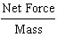, a =
a = 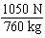 = 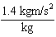 = 1.4 m/s²
a = 1.4 m/s² horizontally

PTS: 1 DIF: L2 OBJ: 12.2.2 STA: 1.12.1

79. ANS:
Weight = Mass Acceleration due to gravity
W = m g
W = 3.5 kg 9.8 m/s² = 34.3 kg·m/s²
W = 34.3 N

PTS: 1 DIF: L2 OBJ: 12.2.3

80. ANS:
Momentum = Mass Velocity
Momentum = 38 kg 2.2 m/s = 83.6 kg·m/s, downriver

PTS: 1 DIF: L2 OBJ: 12.3.2 STA: 1.12.1

81. ANS:
a =
F = m a = 0.3 kg 11 m/s² = 3.3 kg·m/s²
F = 3.3 N

PTS: 1 DIF: L2 OBJ: 12.2.2 STA: 1.12.1

82. ANS:
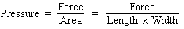 = 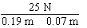
Pressure = 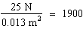 N/m²

PTS: 1 DIF: L2 OBJ: 13.1.1 STA: 1.12.4

83. ANS:
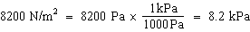

PTS: 1 DIF: L2 OBJ: 13.1.2 STA: 1.12.4

84. ANS:
A hydraulic lift multiples force by a factor equal to the area of the large piston divided by the area of the small piston.

The hydraulic lift will multiply the force by a factor of 9.

The force exerted on Piston 2 is 1350 N.

PTS: 1 DIF: L2 OBJ: 13.2.2 STA: 1.12.4

85. ANS:
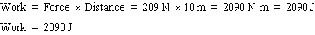

PTS: 1 DIF: L2 OBJ: 14.1.2 STA: 1.12.3

86. ANS:
N·m/s = 320 J/s
Power = 320 J/s = 320 W

PTS: 1 DIF: L2 OBJ: 14.1.3 STA: 1.12.3

87. ANS:
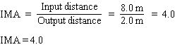

PTS: 1 DIF: L2 OBJ: 14.3.2 STA: 1.12.3

88. ANS:
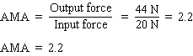

PTS: 1 DIF: L2 OBJ: 14.3.2 STA: 1.12.3

89. ANS:
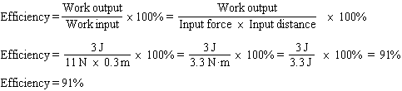

PTS: 1 DIF: L2 OBJ: 14.4.2 STA: 1.12.3

ESSAY

90. ANS:
The steel ball started out slowly. Then it continued to speed up throughout the experiment.

PTS: 1 DIF: L2 OBJ: 1.4.2

91. ANS:
A scientific law is a statement that summarizes a pattern found in nature, without attempting to explain it. A scientific theory explains the pattern.

PTS: 1 DIF: L2 OBJ: 1.2.2

92. ANS:
In peer reviews, scientists review and question other scientists’ data. Scientists also help determine if the data are accurately reported. If the review finds errors in the data, in the conclusions, or in the experimental procedures, the hypothesis may need to be revised.

PTS: 1 DIF: L2 OBJ: 1.4.4

93. ANS:
Speed is equal to the distance traveled divided by the time required to cover the distance. Velocity describes both speed and the direction of motion.

PTS: 1 DIF: L2 OBJ: 11.2.5

94. ANS:
Acceleration can be described as changes in speed, direction, or both. The ball is moving at a constant speed, but its direction is changing continuously. Because its direction is changing, the ball is experiencing continuous acceleration.

PTS: 1 DIF: L2 OBJ: 11.3.2 STA: 1.12.1

95. ANS:
The girl’s displacement from home is 1 block east. The pet store is located 1 block east of her home. The girl walked a total distance of 13 blocks.

PTS: 1 DIF: L2 OBJ: 11.1.4

96. ANS:
On both the calm and windy days, the net force on the biker is zero because the biker is traveling at constant speed. On a calm day, the biker must pedal so that the forward-directed force applied to the bike balances the forces of friction opposing the forward motion. The friction forces primarily take the form rolling friction and fluid friction. On a windy day, the fluid friction force is much greater, so the rider must pedal harder to maintain the same constant speed.

PTS: 1 DIF: L2 OBJ: 12.1.2 | 12.2.2
STA: 1.12.1

97. ANS:
A window may explode outward during a windstorm because the outside pressure is much less than the pressure inside the house. By opening the window, the difference in pressures is reduced.

PTS: 1 DIF: L2 OBJ: 13.2.3 STA: 1.12.4

98. ANS:
0.5-N; because the 0.5-N washer and the cube floating on its own both displace the same volume, the 0.5-N force equals the buoyant force acting on the cube.

PTS: 1 DIF: L2 OBJ: 13.3.2 STA: 1.12.4

