Physics Practice Questions for the Final

Multiple Choice
Identify the choice that best completes the statement or answers the question.

____ 1. Two students are standing on a fire escape, one twice as high as the other. Simultaneously, each drops a ball. If the first ball strikes the ground at time Δt, when will the second ball strike the ground? (Disregard air resistance. Assume a = −g = −9.81 m/s.)
a. | Δt = 4Δt | c. | Δt = Δt
b. | Δt = 2Δt | d. | Δt = Δt

____ 2. A track star in the long jump goes into the jump at 12 m/s and launches herself at 20.0° above the horizontal. What is the magnitude of her horizontal displacement? (Assume no air resistance and that a = –g = –9.81 m/s.)
a. | 4.6 m | c. | 13 m
b. | 9.2 m | d. | 15 m

____ 3. A sculpture is suspended in equilibrium by two cables, one from a wall and the other from the ceiling of a museum gallery. Cable 1 applies a horizontal force to the right of the sculpture and has a tension, F. Cable 2 applies a force upward and to the left at an angle of 37.0° to the negative x-axis and has a tension, F. The gravitational force on the sculpture is 5.00 × 10N. What is F?
a. | 4440 N | c. | 8310 N
b. | 6640 N | d. | 3340 N

____ 4. An ice skater moving at 10.0 m/s coasts to a halt in 1.0 × 10 m on a smooth ice surface. What is the coefficient of friction between the ice and the skates?
a. | 0.025 | c. | 0.102
b. | 0.051 | d. | 0.205

____ 5. The sun is composed mostly of hydrogen. The mass of the sun is 2.0 × 10 kg, and the mass of a hydrogen atom is 1.67 × 10 kg. Estimate the number of atoms in the sun.
a. | 10 | c. | 10
b. | 10 | d. | 10

____ 6. A sled traveling at a speed of 3.0 m/s slows to a stop 4.0 m from the point where its passenger rolled off. What is the magnitude of the horizontal net force that slows the 110 N sled? (Assume a_{g} = 9.81 m/s.)
a. | 130 N | c. | 37 N
b. | 34 N | d. | 13 N

____ 7. A book with a mass of 2.0 kg is held in equilibrium on a board with a slope of 60.0° by a horizontal force. What is the normal force exerted on the book?
a. | 39 N | c. | 15 N
b. | 61 N | d. | 34 N

____ 8. A crate is carried in a pickup truck traveling horizontally at 15.0 m/s. The truck applies the brakes for a distance of 28.7 m while stopping with uniform acceleration. What is the coefficient of static friction between the crate and the truck bed if the crate does not slide?
a. | 0.400 | c. | 0.892
b. | 0.365 | d. | 0.656

____ 9. Which of the following expressions gives units of kg•m⁄s?
a. | m•Δx ⁄(Δt) | c. | m•(Δx)⁄Δt
b. | m•(Δx)⁄(Δt) | d. | (Δt)⁄ m•(Δx)

____ 10. If the change in position Δx is related to velocity v (with units of m/s) in the equation Δx = Av, the constant A has which dimension?
a. | m/s | c. | s
b. | m | d. | m

____ 11. For the winter, a duck flies 10.0 m/s due south against a gust of wind with a speed of 2.5 m/s. What is the resultant velocity of the duck?
a. | 12.5 m/s south | c. | 7.5 m/s south
b. | –12.5 m/s south | d. | –7.5 m/s south

____ 12. There are six books in a stack, and each book weighs 5 N. The coefficient of static friction between the books is 0.2. With what horizontal force must one push to start sliding the top five books off the bottom one?
a. | 1 N | c. | 3 N
b. | 5 N | d. | 7 N

____ 13. A construction worker pushes a wheelbarrow 5.0 m with a horizontal force of 50.0 N. How much work is done by the worker on the wheelbarrow?
a. | 10 J | c. | 250 J
b. | 55 J | d. | 1250 J

____ 14. What is the kinetic energy of a 0.135 kg baseball thrown at 40.0 m/s?
a. | 54.0 J | c. | 108 J
b. | 87.0 J | d. | 216 J

____ 15. A 0.2 kg baseball is pitched with a velocity of 40 m/s and is then batted to the pitcher with a velocity of 60 m/s. What is the magnitude of change in the ball’s momentum?
a. | 2 kg•m/s | c. | 8 kg•m/s
b. | 4 kg•m/s | d. | 20 kg•m/s

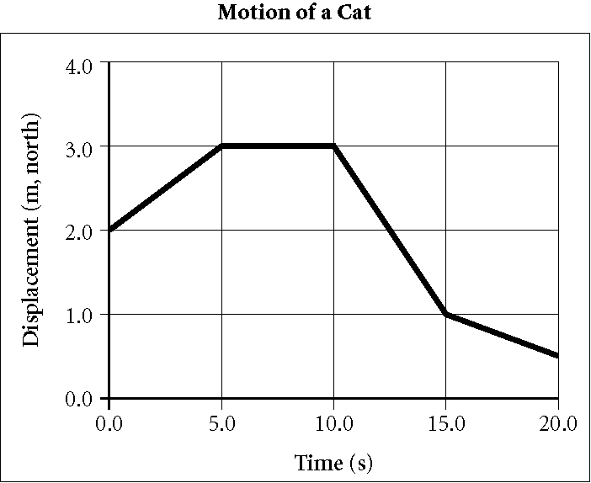

____ 16. According to the graph above, the cat has the fastest speed during which interval?
a. | 0.0–5.0 s | c. | 10.0–15.0 s
b. | 5.0–10.0 s | d. | 15.0–20.0 s

____ 17. When a car’s velocity is positive and its acceleration is negative, what is happening to the car’s motion?
a. | The car slows down. | c. | The car travels at constant speed.
b. | The car speeds up. | d. | The car remains at rest.

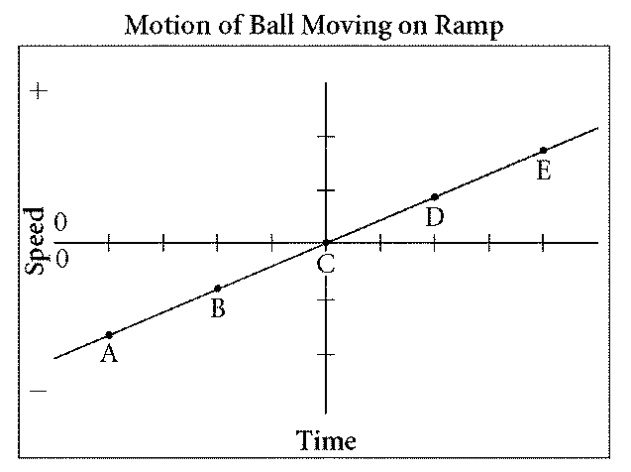

____ 18. The graph above describes the motion of a ball. At what point is the speed of the ball equal to its speed at B?
a. | A | c. | D
b. | C | d. | none of the above

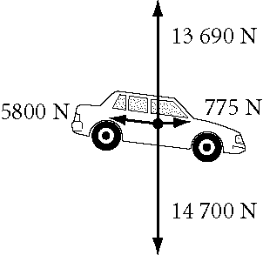

____ 19. The free-body diagram shown above represents a car being pulled by a towing cable. In the diagram, which of the following is the gravitational force acting on the car?
a. | 5800 N | c. | 14 700 N
b. | 775 N | d. | 13 690 N

____ 20. A ball is dropped from a person’s hand and falls to Earth. Identify an action-reaction pair in this situation.
a. | The hand exerts a force on the ball; Earth exerts a force on the hand.
b. | Earth exerts a force on the ball; the hand exerts a force on Earth.
c. | Earth exerts a force on the hand; the hand exerts a force on the ball.
d. | Earth exerts a force on the ball; the ball exerts a force on Earth.

____ 21. A child moving at constant velocity carries a 2 N ice-cream cone 1 m across a level surface. What is the net work done on the ice-cream cone?
a. | 0 J | c. | 2 J
b. | 0.5 J | d. | 20 J

____ 22. Ball A has triple the mass and speed of ball B. What is the ratio of the kinetic energy of ball A to ball B.
a. | 3 | c. | 9
b. | 6 | d. | 27

____ 23. If friction is the only force acting on an object during a given physical process, which of the following assumptions can be made in regard to the object’s kinetic energy?
a. | The kinetic energy decreases.
b. | The kinetic energy increases.
c. | The kinetic energy remains constant.
d. | The kinetic energy decreases and then increases.

____ 24. For which of the following situations is the conservation of mechanical energy most likely to be a valid assumption?
a. | A skateboard rolls across a sewer grate.
b. | A parachutist falls from a plane.
c. | You rub your hands together to keep warm.
d. | A soccer ball flies through the air.

____ 25. Two skaters stand facing each other. One skater’s mass is 60 kg, and the other’s mass is 72 kg. If the skaters push away from each other without spinning,
a. | the lighter skater has less momentum.
b. | their momenta are equal but opposite.
c. | their total momentum doubles.
d. | their total momentum decreases.

____ 26. A lack of precision in scientific measurements typically arises from
a. | limitations of the measuring instrument.
b. | human error.
c. | lack of calibration.
d. | too many significant figures.

____ 27. What is the speed of an object at rest?
a. | 0.0 m/s | c. | 9.8 m/s
b. | 1.0 m/s | d. | 9.81 m/s

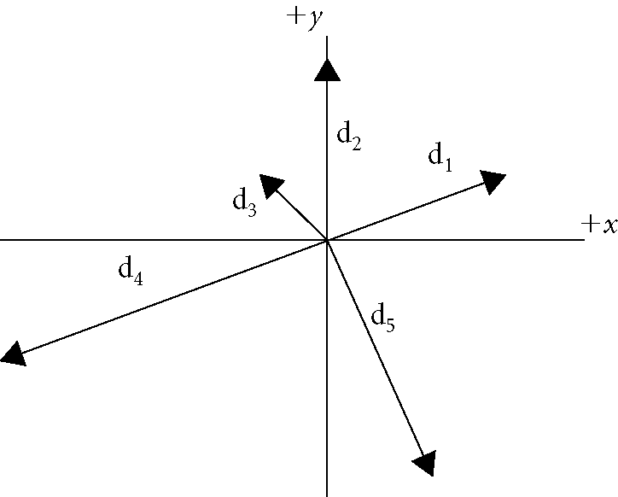

____ 28. Which displacement vectors shown in the figure above have vertical components that are equal?
a. | d and d | c. | d and d
b. | d and d | d. | d and d

____ 29. Which of the following forces arises from direct physical contact between two objects?
a. | gravitational force | c. | contact force
b. | fundamental force | d. | field force

____ 30. A free-body diagram represents all of the following except
a. | the object. | c. | forces exerted by the object.
b. | forces as vectors. | d. | forces exerted on the object.

____ 31. The magnitude of the gravitational force acting on an object is
a. | frictional force. | c. | inertia.
b. | weight. | d. | mass.

____ 32. What are the units of the coefficient of friction?
a. | N | c. | N
b. | 1/N | d. | The coefficient of friction has no units.

____ 33. Which of the following energy forms is associated with an object in motion?
a. | potential energy | c. | nonmechanical energy
b. | elastic potential energy | d. | kinetic energy

____ 34. Which of the following is a true statement about the conservation of energy?
a. | Potential energy is always conserved.
b. | Kinetic energy is always conserved.
c. | Mechanical energy is always conserved.
d. | Total energy is always conserved.

____ 35. Which of the following is the rate at which energy is transferred?
a. | potential energy | c. | mechanical energy
b. | kinetic energy | d. | power

____ 36. A more powerful motor can do
a. | more work in a longer time interval.
b. | the same work in a shorter time interval.
c. | less work in a longer time interval.
d. | the same work in a longer time interval.

____ 37. A rubber ball moving at a speed of 5 m/s hit a flat wall and returned to the thrower at 5 m/s. The magnitude of the momentum of the rubber ball
a. | increased. | c. | remained the same.
b. | decreased. | d. | was not conserved.

____ 38. Which of the following equations can be used to directly calculate the change in an object’s momentum?
a. | p = mv | c. | p = FΔt
b. | 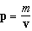 | d. | Δp = FΔt

____ 39. In a two-body collision,
a. | momentum is always conserved.
b. | kinetic energy is always conserved.
c. | neither momentum nor kinetic energy is conserved.
d. | both momentum and kinetic energy are always conserved.

____ 40. The law of conservation of momentum states that
a. | the total initial momentum of all objects interacting with one another usually equals the total final momentum.
b. | the total initial momentum of all objects interacting with one another does not equal the total final momentum.
c. | the total momentum of all objects interacting with one another is zero.
d. | the total momentum of all objects interacting with one another remains constant regardless of the nature of the forces between the objects.

____ 41. Which of the following statements about the conservation of momentum is not correct?
a. | Momentum is conserved for a system of objects pushing away from each other.
b. | Momentum is not conserved for a system of objects in a head-on collision.
c. | Momentum is conserved when two or more interacting objects push away from each other.
d. | The total momentum of a system of interacting objects remains constant regardless of forces between the objects.

____ 42. A billiard ball collides with a second identical ball in an elastic head-on collision. What is the kinetic energy of the system after the collision compared with the kinetic energy before the collision?
a. | unchanged | c. | two times as great
b. | one-fourth as great | d. | four times as great

Short Answer

43. Convert 92 × 10 km to decimeters using scientific notation.

44. Convert 1 μm to meters using scientific notation.

45. Convert g to kilograms using scientific notation.

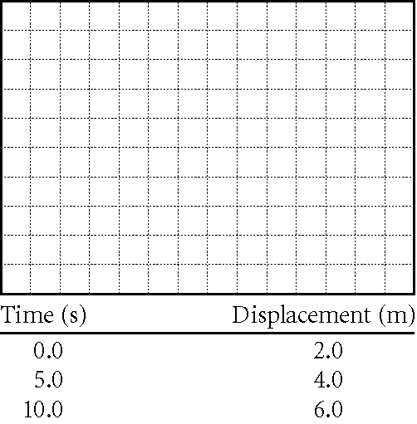

46. Construct a graph of position versus time of a jogger, using the data in the table above. Explain how the graph indicates that the jogger’s speed is constant.

47. Construct a graph of position versus time of a jogger, using the data in the table above. What is the average velocity of the jogger?

48. A motorized scooter starts from rest and accelerates for 4 s at 2 m/s. It continues at a constant speed for 6 s. Graph the scooter’s velocity versus time. What is the scooter’s average velocity for the interval 0–4 s?

49. What is the kinetic energy of a 1.5 × 10 kg car traveling at 25 m/s?

Problem

50. A stroller walks the first half of a straight 1.0 km trail at a steady pace of 0.75 m/s, east. He walks the second half at a constant stride of 0.60 m/s, east. What is his average velocity along the trail?

51. Two cars pass each other traveling at the same speed. One car has a constant velocity of 15.0 m/s, east. The other car has a constant acceleration of 1.00 m/s, west. How much time will have elapsed until the cars are 164 m apart?

52. A pair of glasses are dropped from the top of a 32.0 m high stadium. A pen is dropped from the same position 2.00 s later. How high above the ground is the pen when the glasses hit the ground? (Disregard air resistance. a = −g = −9.81 m/s.)

53. A pebble falls from the bottom of the basket of a hot-air balloon that is rising at 1.0 m/s. After 3.0 seconds, how far below the basket is the pebble? (Assume no air resistance and a = −g = −9.81 m/s.)

54. A cow ambles through a break in the barnyard fence and wanders 24 m at 40.0° north of east, and then 13 m east. If the cow’s wanderings last 3.0 minutes, what is the cow’s average velocity?

55. While grazing, a caribou treks 125 m at 35.0° west of south, and then 105 m west. What is the caribou’s resultant displacement?

56. An hockey puck travels 2.00 m at 10.0° east of south before ricocheting 2.50 m at 75.0° north of east. What is the puck’s resultant displacement?

57. A firefighter 50.0 m away from a burning building directs a stream of water from a fire hose at an angle of 30.0° above the horizontal. If the velocity of the stream is 40.0 m/s, at what height will the stream of water strike the building? (a = −g = −9.81 m/s)

58. A fox sees a piece of carrion being thrown from a hawk’s nest and rushes to snatch it. The nest is 14.0 m high, and the carrion is thrown with a horizontal velocity of 1.5 m/s. The fox is 7.0 m from the base of the tree. What is the magnitude of the fox’s average velocity if it grabs the carrion in its mouth just as it touches the ground? (Assume no air resistance and that a = −g = −9.81 m/s.)

59. A pebble falls vertically from the edge of a cliff 24 m high. After falling 1.0 s, the pebble glances a small rock protruding from the face of the cliff. The impact with ledge has negligible effect on the pebble’s vertical motion. However, the pebble is deflected perpendicular to the face of the cliff with a horizontal velocity of 5 cm/s. How far from the base of the cliff does the pebble land? (Assume no air resistance and that a = −g = −9.81 m/s.)

60. A cat pushes a ball from a 10.00 m high window, giving it a horizontal velocity of 0.20 m/s. As it falls, the ball is deflected from the edge of a 3.00 m high downspout. The impact with the downspout has little effect on the ball’s vertical motion. However, the ball’s horizontal velocity increases by 0.05 m/s. How far from the base of the building does the ball land? (Assume no air resistance and that a = −g = −9.81 m/s.)

61. Experiencing a constant horizontal 1.10 m/s wind, a hot-air balloon ascends from the launch site at a constant vertical speed of 2.50 m/s. At a height of 205 m, the balloonist maintains constant altitude for 10.0 s before releasing a small sandbag. How far from the launch site does the sandbag land?

62. A boat moves at 10.00 m/s relative to the water. If the boat is in a river where the current is 2.00 m/s, how long does it take the boat to make a complete round trip of 1000.0 m upstream followed by 1000.0 m downstream?

63. A trapeze artist is momentarily held to one side of a swing by a partner so that both of the swing ropes are at an angle of 30.0° with the vertical. In such a condition of static equilibrium, what is the magnitude of the horizontal force being applied by the partner? The force due to gravity on the artist is 8.00 × 10 N.

64. A couch with a mass of 1.00 × 10 kg is placed on an adjustable ramp connected to a truck. As one end of the ramp is raised, the couch begins to move downward. If the couch slides down the ramp with an acceleration of 0.70 m/s when the ramp angle is 25.0°, what is the coefficient of kinetic friction between the ramp and the couch? (g = 9.81 m/s)

65. An Olympic skier moving at 20.0 m/s down a 30.0° slope encounters a region of wet snow and slides 145 m before coming to a halt. What is the coefficient of friction between the skis and the snow? (g = 9.81 m/s²)

66. A professional skier starts from rest and reaches a speed of 56 m/s on a ski slope angled 30.0° above the horizontal. Using the work-kinetic energy theorem and disregarding friction, find the minimum distance along the slope the skier would have to travel in order to reach this speed.

67. A 15.0 kg crate, initially at rest, slides down a ramp 2.0 m long and inclined at an angle of 20.0° with the horizontal. Using the work-kinetic energy theorem and disregarding friction, find the velocity of the crate at the bottom of the ramp. (g = 9.81 )

68. A 40.0 N crate starting at rest slides down a rough 6.0 m long ramp inclined at 30.0° with the horizontal. The force of friction between the crate and ramp is 6.0 N. Using the work-kinetic energy theorem, find the velocity of the crate at the bottom of the incline.

69. A child riding a bicycle has a total mass of 40.0 kg. The child approaches the top of a hill that is 10.0 m high and 100.0 m long at 5.0 m/s. If the force of friction between the bicycle and the hill is 20.0 N, what is the child’s velocity at the bottom of the hill? (Assume no air resistance and that g = 9.81 m/s.)

70. A 1.00 × 10 kg sports car accelerates from rest to 25.0 m/s in 7.50 s. What is the average power output of the automobile engine?

71. Water flows over a section of Niagara Falls at a rate of 1.20 × 10 kg/s and falls 50.0 m. What is the power of the waterfall?

72. A 65 kg trapeze artist falls straight down onto a safety net. The trapeze artist’s initial speed as she hits the net is 9.9 m/s, and the net stretches 1.5 m vertically as she comes to a stop. What average net force does the trapeze artist experience while the net breaks her fall? How many “g’s” of acceleration does she experience on average? (1 g = 9.81 m/s)

A 68.0 kg diver jumps off a diving platform, rises about 1 m above the platform, then falls to the pool.

73. Use the impulse-momentum theorem to find the diver’s momentum after falling for 1.00 s.

74. A train with a mass of 1.8 × 10 kg is moving at 15 m/s when the engineer applies the brakes. If the braking force is constant at 3.5 × 10 N, how long does it take the train to stop? How far does the train travel during this time?

75. A bullet with a mass of 5.00 × 10 kg is loaded into a gun. The loaded gun has a mass of 0.52 kg. The bullet is fired, causing the empty gun to recoil at a speed of 2.1 m/s. What is the speed of the bullet?

76. Two ice-skaters, each with a mass of 50 kg, are stationary on a frictionless ice pond. One skater throws a 0.2 kg ball at 5 m/s to the other skater, who catches it. What are the velocities of the skaters when the ball is caught?

77. A bullet with a mass of 6.00 g is fired through a 1.25 kg block of wood on a frictionless surface. The initial speed of the bullet is 896 m/s, and the speed of the bullet after it exits the block is 435 m/s. At what speed does the block move after the bullet passes through it?

78. Two snowballs with masses of 0.40 kg and 0.60 kg, respectively, collide head-on and combine to form a single snowball. The initial speed for each is 15 m/s. If the velocity of the new combined snowball is 3.0 m/s after the collision, what is the decrease in kinetic energy?

79. A 1.5 × 10 kg truck moving at 15 m/s strikes a 7.5 × 10 kg automobile stopped at a traffic light. The vehicles hook bumpers and skid together at 10.0 m/s. What is the decrease in kinetic energy?

80. A clay ball with a mass of 0.35 kg has an initial speed of 4.2 m/s. It strikes a 3.5 kg clay ball at rest, and the two balls stick together and remain stationary. What is the decrease in kinetic energy of the 0.35 kg ball?

81. A 0.10 kg object makes an elastic head-on collision with a 0.15 kg stationary object. The final velocity of the 0.10 kg object after the collision is 0.045 m/s in the direction opposite its initial movement. The final velocity of the 0.15 kg object after the collision is 0.16 m/s in the same direction as the object which strikes it. What was the initial velocity of the 0.10 kg object?

82. A bowling ball with a mass of 7.0 kg strikes a pin that has a mass of 2.0 kg. The pin flies forward with a velocity of 6.0 m/s, and the ball continues forward at 4.0 m/s. What was the original velocity of the ball?

83. A 15 g marble moves to the right at 3.6 m/s and makes an elastic head-on collision with a 22 g marble. The final velocity of the 15 g marble is 5.4 m/s to the left, and the final velocity of the 22 g marble is 2.0 m/s to the right. What was the initial velocity of the 22 g marble?

84. A clay ball with a mass of 0.35 kg strikes another 0.35 kg clay ball at rest, and the two balls stick together. The final velocity of the balls is 2.1 m/s north. What was the first ball’s initial velocity?

85. A 90 kg halfback runs north and is tackled by a 120 kg opponent running south at 4 m/s. The collision is perfectly inelastic. Just after the tackle, both players move at a velocity of 2 m/s north. Calculate the velocity of the 90 kg player just before the tackle.

Physics Practice Questions for the Final
Answer Section

MULTIPLE CHOICE

1. ANS: C

Given
a = −g
Δx = 2Δx
v = v = 0

Solution
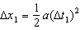
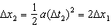

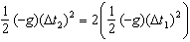

PTS: 1 DIF: IIIC OBJ: 2-3.3

2. ANS: B
Given
v_{i} = 12 m/s at 20.0° above the horizontal

Solution
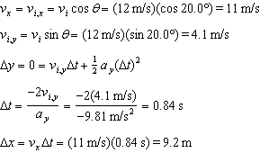

PTS: 1 DIF: IIIC OBJ: 3-3.3

3. ANS: C

Given
F = 5.00 × 10 N
θ = 37.0°

Solution
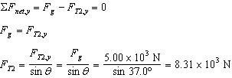

PTS: 1 DIF: IIIC OBJ: 4-2.3

4. ANS: B

Given
v = 10.0 m/s
g = 9.81 m/s
Δx = 1.0 × 10 m

Solution
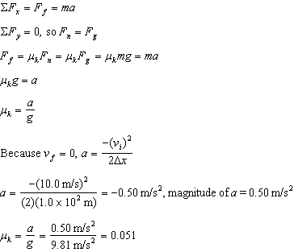

PTS: 1 DIF: IIIC OBJ: 4-4.4

5. ANS: B
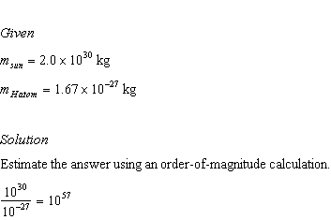

PTS: 1 DIF: IIIB OBJ: 1-3.4

6. ANS: D

Given
v = 3.0 m/s
Δx = 4.0 m
v = 0.0 m/s

Solution
, so 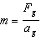
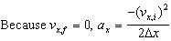
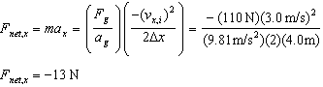
magnitude of horizontal net force = 13 N

PTS: 1 DIF: IIIB OBJ: 4-3.2

7. ANS: A

Given
m = 2.0 kg
θ = 60.0°
g = 9.81 m/s

Solution
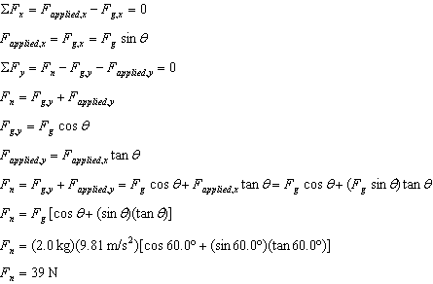

PTS: 1 DIF: IIIB OBJ: 4-4.2

8. ANS: A

Given
v = 15.0 m/s
Δx = 28.7 m
g = 9.81 m/s

Solution
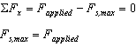
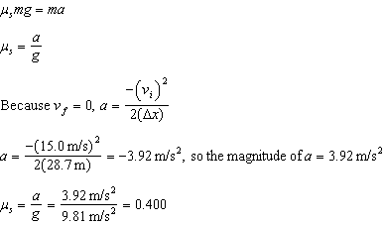

PTS: 1 DIF: IIIB OBJ: 4-4.4

9. ANS: B
Solution
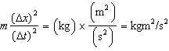

PTS: 1 DIF: IIIA OBJ: 1-3.3

10. ANS: C
Solution
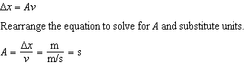

PTS: 1 DIF: IIIA OBJ: 1-3.3

11. ANS: C
Given
v = 10.0 m/s south
v = 2.5 m/s north

Solution
v_{R}

PTS: 1 DIF: IIIA OBJ: 3-1.2

12. ANS: B

Given
F = 5 N
μ = 0.2

Solution
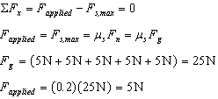

PTS: 1 DIF: IIIA OBJ: 4-4.4

13. ANS: C

Given
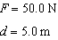

Solution

PTS: 1 DIF: IIIA OBJ: 5-1.4

14. ANS: C

Given
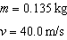

Solution

PTS: 1 DIF: IIIA OBJ: 5-2.2

15. ANS: D
Given
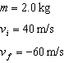

Solution

PTS: 1 DIF: IIIA OBJ: 6-1.3

16. ANS: C PTS: 1 DIF: II OBJ: 2-1.3

17. ANS: A PTS: 1 DIF: II OBJ: 2-2.1

18. ANS: C PTS: 1 DIF: II OBJ: 2-2.2

19. ANS: C PTS: 1 DIF: II OBJ: 4-1.2

20. ANS: D PTS: 1 DIF: II OBJ: 4-3.3

21. ANS: A PTS: 1 DIF: II OBJ: 5-1.4

22. ANS: D PTS: 1 DIF: II OBJ: 5-2.2

23. ANS: A PTS: 1 DIF: II OBJ: 5-2.3

24. ANS: D PTS: 1 DIF: II OBJ: 5-3.1

25. ANS: B PTS: 1 DIF: II OBJ: 6-2.2

26. ANS: A PTS: 1 DIF: I OBJ: 1-2.3

27. ANS: A PTS: 1 DIF: I OBJ: 2-1.1

28. ANS: B PTS: 1 DIF: I OBJ: 3-2.3

29. ANS: C PTS: 1 DIF: I OBJ: 4-1.1

30. ANS: C PTS: 1 DIF: I OBJ: 4-1.2

31. ANS: B PTS: 1 DIF: I OBJ: 4-4.1

32. ANS: D PTS: 1 DIF: I OBJ: 4-4.4

33. ANS: D PTS: 1 DIF: I OBJ: 5-2.1

34. ANS: D PTS: 1 DIF: I OBJ: 5-3.1

35. ANS: D PTS: 1 DIF: I OBJ: 5-4.1

36. ANS: B PTS: 1 DIF: I OBJ: 5-4.3

37. ANS: C PTS: 1 DIF: I OBJ: 6-1.3

38. ANS: D PTS: 1 DIF: I OBJ: 6-1.4

39. ANS: A PTS: 1 DIF: I OBJ: 6-2.3

40. ANS: D PTS: 1 DIF: I OBJ: 6-2.3

41. ANS: B PTS: 1 DIF: I OBJ: 6-2.3

42. ANS: A PTS: 1 DIF: I OBJ: 6-3.3

SHORT ANSWER

43. ANS:

Solution
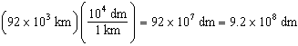

PTS: 1 DIF: IIIA OBJ: 1-2.2

44. ANS:

Solution
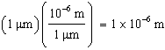

PTS: 1 DIF: IIIA OBJ: 1-2.2

45. ANS:

Solution
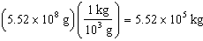

PTS: 1 DIF: IIIA OBJ: 1-2.2

46. ANS:
The jogger is moving at a constant speed because the position versus time graph is a straight line with a positive slope.

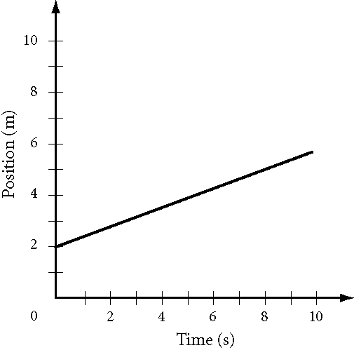

PTS: 1 DIF: IIIA OBJ: 2-1.3

47. ANS:
+0.40 m/s

Given
x = 2.8 m
x = 5.2 m
t = 2.0 s
t = 8.0 s

Solution
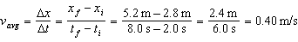

PTS: 1 DIF: IIIA OBJ: 2-1.3

48. ANS:
+2.0 m/s

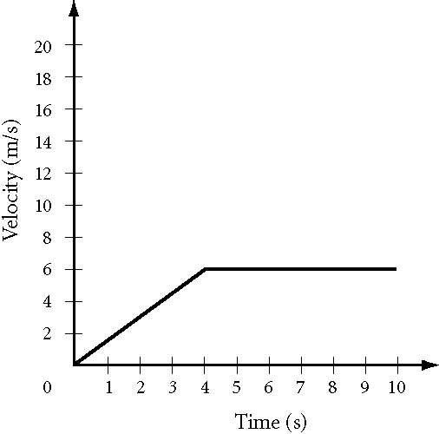

Given
v = 0.0 m/s
v = 4.0 m/s

Solution
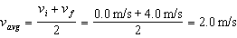

PTS: 1 DIF: IIIA OBJ: 2-2.2

49. ANS:
4.7 × 10 J

Given
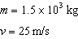

Solution

PTS: 1 DIF: IIIA OBJ: 5-2.2

PROBLEM

50. ANS:
0.67 m/s, east

Given
Δx = Δx =
v = 0.75 m/s
v = 0.60 m/s

Solution
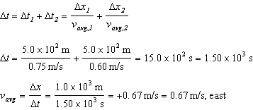

PTS: 1 DIF: IIIC OBJ: 2-1.2

51. ANS:
5.0 s

Given

⏐v⏐=⏐v⏐= 15.0 m/s
a = 1.00 m/s
d = 164 m

Solution
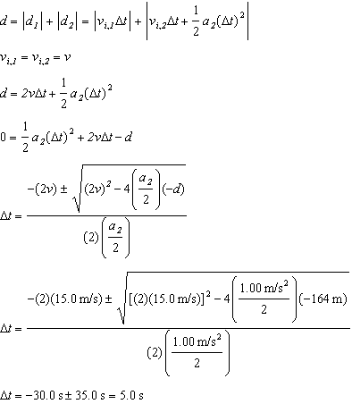

PTS: 1 DIF: IIIC OBJ: 2-2.3

52. ANS:
30.5 m

Given
a = −g = −9.81 m/s
v = 0.0 m/s
Δx₁ = −32.0 m
v_{i,2} = 0.0 m/s
Δt = 2.00 s

Solution
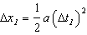
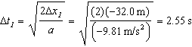
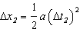
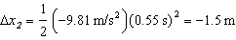
h = 32.0 m – 1.5 m = 30.5 m

PTS: 1 DIF: IIIC OBJ: 2-3.3

53. ANS:
44 m

Given
a = −g = −9.81 m/s
v = v = 1.0 m/s
Δt = 3.0 s

Solution
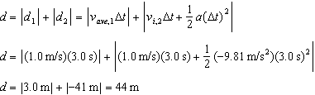

PTS: 1 DIF: IIIC OBJ: 2-3.3

54. ANS:
0.19 m/s, 26° north of east

Given
d = 24 m θ = 40.0° north of east
d = 13 m θ = 0° east
Δt = (3.0 min)(60 s/min) = 180 s

Solution
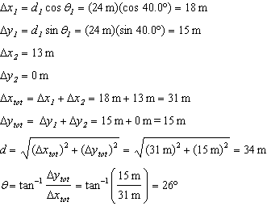
d = 34 m, 26° north of east

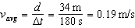

v_{avg} = 0.19 m/s, 26° north of east

PTS: 1 DIF: IIIC OBJ: 3-2.4

55. ANS:
204 m, 59.9° west of south

Given
d = 125 m θ = 35.0° west of south
d = 105 m θ = 90.0° west of south

Solution
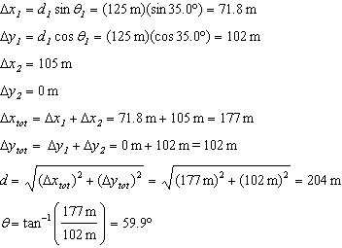
d = 204 m, 59.9° west of south

PTS: 1 DIF: IIIC OBJ: 3-2.4

56. ANS:
1.09 m at 24° north of east

Given
d = 2.00 m θ = 10.0° east of south
d = 2.50 m θ = 75.0° north of east

Solution
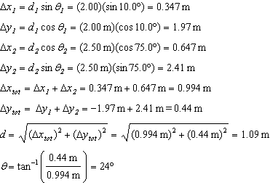
d = 1.09 m at 24° north of east

PTS: 1 DIF: IIIC OBJ: 3-2.4

57. ANS:
18.7 m

Given
v = 40.0 m/s θ = 30.0°
Δx = 50.0 m

Solution
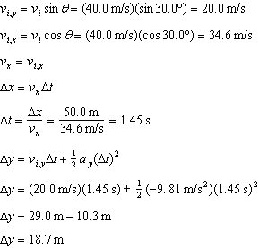

PTS: 1 DIF: IIIC OBJ: 3-3.3

58. ANS:
2.6 m/s

Given
v = v = 1.5 m/s horizontally
Δy = −14.0 m
d = 7.0 m

Solution
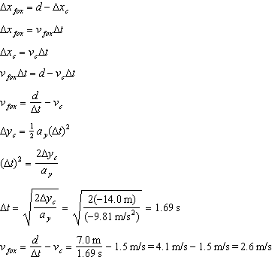

PTS: 1 DIF: IIIC OBJ: 3-3.3

59. ANS:
6 cm

Given
Δy = −24 m
v = 5 cm/s

Solution
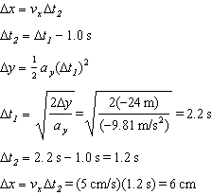

PTS: 1 DIF: IIIC OBJ: 3-3.3

60. ANS:
0.30 m

Given
Δy = −10.00 m
v = 0.20 m/s
Δy = −3.00 m
Δv = 0.05 m/s

Solution
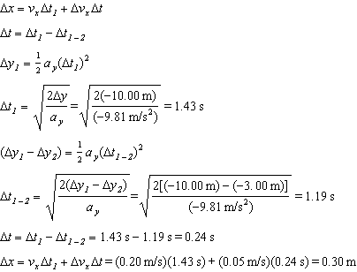

PTS: 1 DIF: IIIC OBJ: 3-3.3

61. ANS:
108 m

Given
v = 1.10 m/s
v = 2.50 m/s
Δy = 205 m
Δy = −205 m
Δt = 10.0 s

Solution
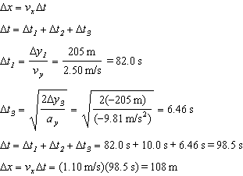

PTS: 1 DIF: IIIC OBJ: 3-3.3

62. ANS:
208 s

Given
v_{rg} = velocity of river to ground = 2.00 m/s downstream
v_{br} = velocity of boat to river = 10.00 m/s
Δx = 1000.0 m downstream
Δx = −1000.0 m downstream
v_{bg} = velocity of boat to ground

Solution
downstream
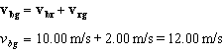
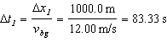
upstream
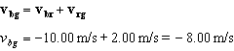
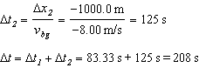

PTS: 1 DIF: IIIC OBJ: 3-4.2

63. ANS:
231 N

Given
F = 8.00 × 10 N
θ = 30.0°

Solution
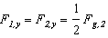
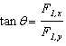
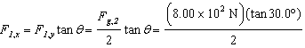

PTS: 1 DIF: IIIC OBJ: 4-2.3

64. ANS:
0.387

Given
m = 1.00 × 10 kg
a = 0.70 m/s
θ = 25.0°
g = 9.81 m/s

Solution
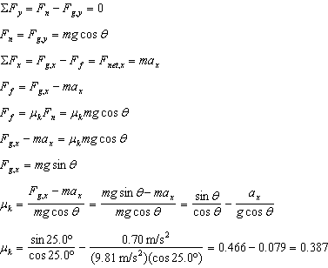

PTS: 1 DIF: IIIC OBJ: 4-4.4

65. ANS:
0.415

Given:
v_{x,i} = 20.0 m/s
Δx = 145 m
θ = 30.0º
g = 9.81 m/s²

Solution
Choose a coordinate system such that the positive x-direction is down the ski slope. The force of friction will be in the negative x-direction.
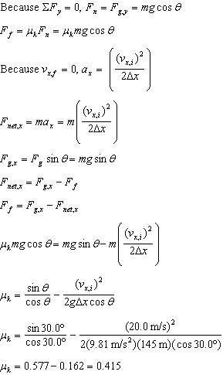

PTS: 1 DIF: IIIC OBJ: 4-4.4

66. ANS:
320 m

Given
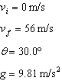

Solution
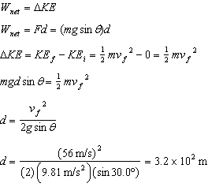

PTS: 1 DIF: IIIC OBJ: 5-2.3

67. ANS:
3.7 m/s

Given
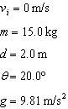

Solution
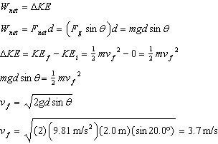

PTS: 1 DIF: IIIC OBJ: 5-2.3

68. ANS:
6.4 m/s

Given
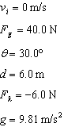

Solution
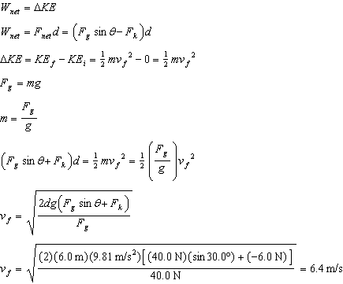

PTS: 1 DIF: IIIC OBJ: 5-2.3

69. ANS:
11 m/s

Given
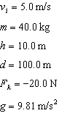

Solution
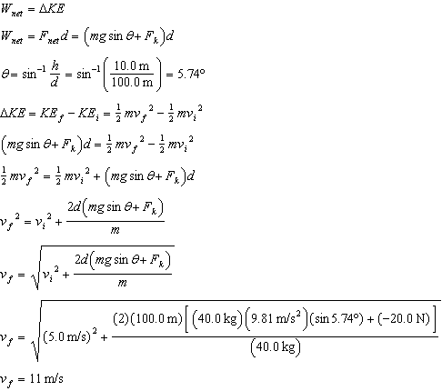

PTS: 1 DIF: IIIC OBJ: 5-2.3

70. ANS:
41.6 kW

Given
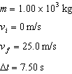

Solution
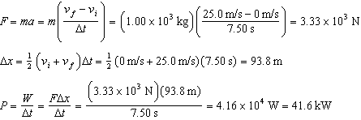

PTS: 1 DIF: IIIC OBJ: 5-4.2

71. ANS:
589 MW

Given
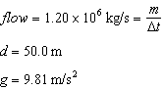

Solution
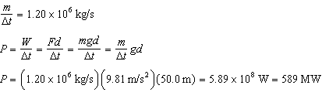

PTS: 1 DIF: IIIC OBJ: 5-4.2

72. ANS:
2.1 × 10 N upward; 3.3g

Given
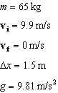

Solution
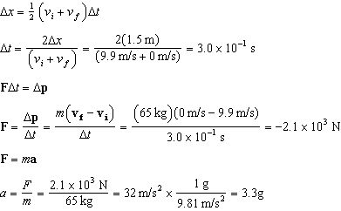

PTS: 1 DIF: IIIC OBJ: 6-1.4

73. ANS:
667 kg•m/s downward

Given
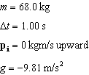

Solution
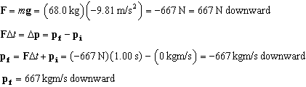

PTS: 1 DIF: IIIC OBJ: 6-1.4

74. ANS:
77 s; 5.8 × 10 m

Given
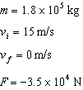

Solution
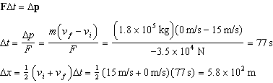

PTS: 1 DIF: IIIC OBJ: 6-1.4

75. ANS:
2.2 × 10 m/s

Given
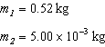
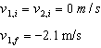

Solution
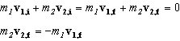
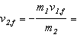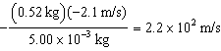

PTS: 1 DIF: IIIC OBJ: 6-2.4

76. ANS:
Skater 1 has a velocity of 2 × 10 m/s away from skater 2.
Skater 2 has a velocity of 2 × 10 m/s away from skater 1.

Given
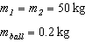
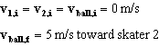

Solution
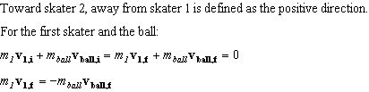
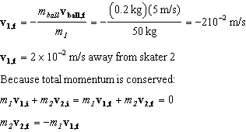
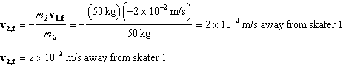

PTS: 1 DIF: IIIC OBJ: 6-2.4

77. ANS:
2.21 m/s

Given
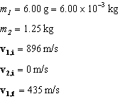

Solution
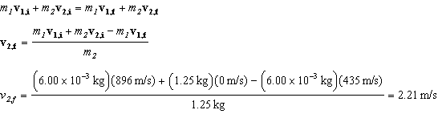

PTS: 1 DIF: IIIC OBJ: 6-2.4

78. ANS:
1.1 × 10 J

Given
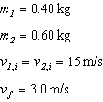

Solution
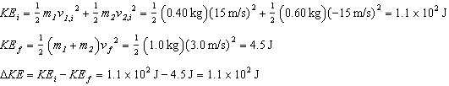

PTS: 1 DIF: IIIC OBJ: 6-3.2

79. ANS:
6.0 × 10 J

Given
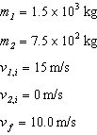

Solution
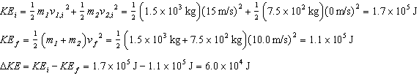

PTS: 1 DIF: IIIC OBJ: 6-3.2

80. ANS:
3.1 J

Given
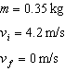

Solution
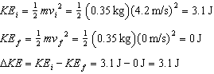

PTS: 1 DIF: IIIC OBJ: 6-3.2

81. ANS:
0.20 m/s forward

Given
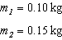
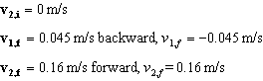

Solution
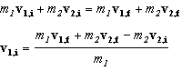

PTS: 1 DIF: IIIC OBJ: 6-3.4

82. ANS:
5.7 m/s forward

Given
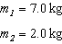
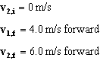

Solution
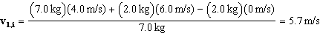 forward

PTS: 1 DIF: IIIC OBJ: 6-3.4

83. ANS:
4.1 m/s to the left

Given
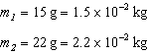
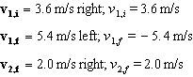

Solution
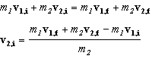
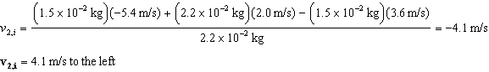

PTS: 1 DIF: IIIC OBJ: 6-3.4

84. ANS:
4.2 m/s to the north

Given
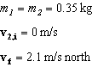

Solution
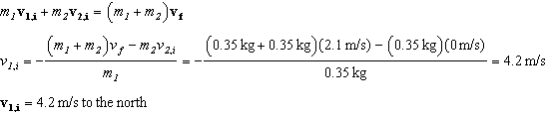

PTS: 1 DIF: IIIC OBJ: 6-3.4

85. ANS:
10 m/s to the north

Given
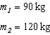
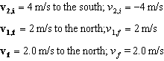

Solution
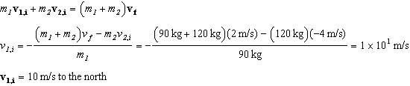

PTS: 1 DIF: IIIC OBJ: 6-3.4

